Week 10 - S10 - Advanced OOP - UML Diagram - Practice Problem

**Name:** Ramesh Harisabapathi Chettiar

**Date of Submission:** 17/10/2025

**QNO1🡪**

Problem Statement: Design a simple Library Management System that tracks books

and Members.

● A Library contains multiple Books.

● A Member can borrow multiple Books.

● If the Library is deleted, all its Books are also removed (Composition

relationship).

**LibraryDemo.java**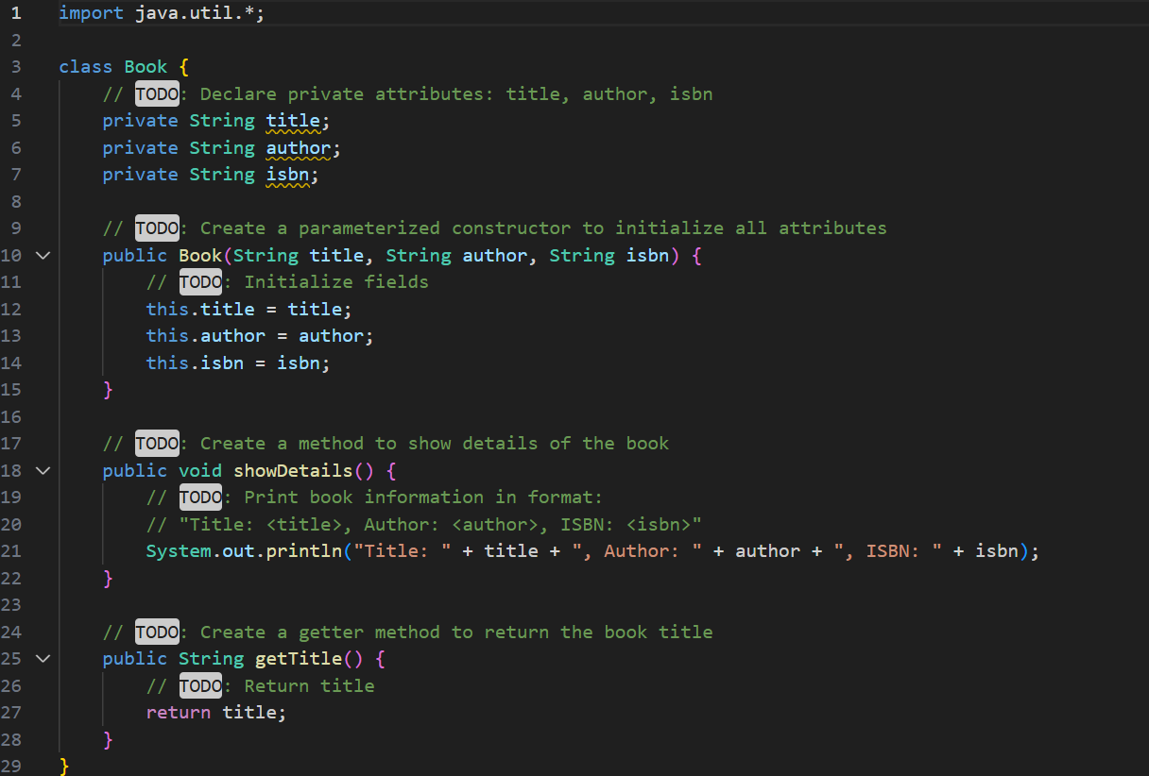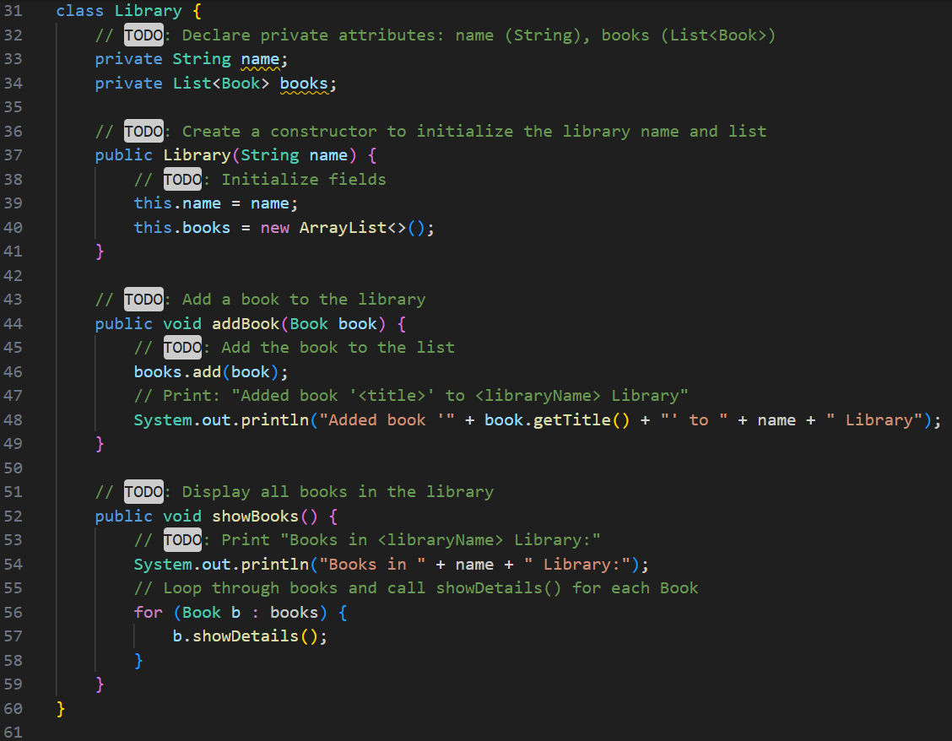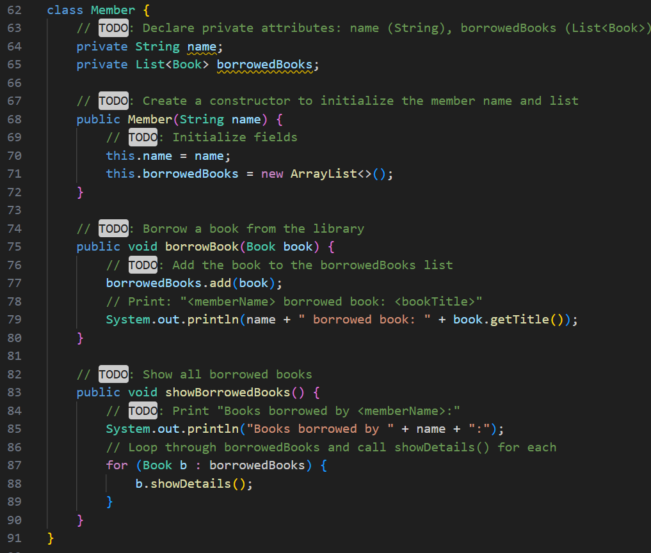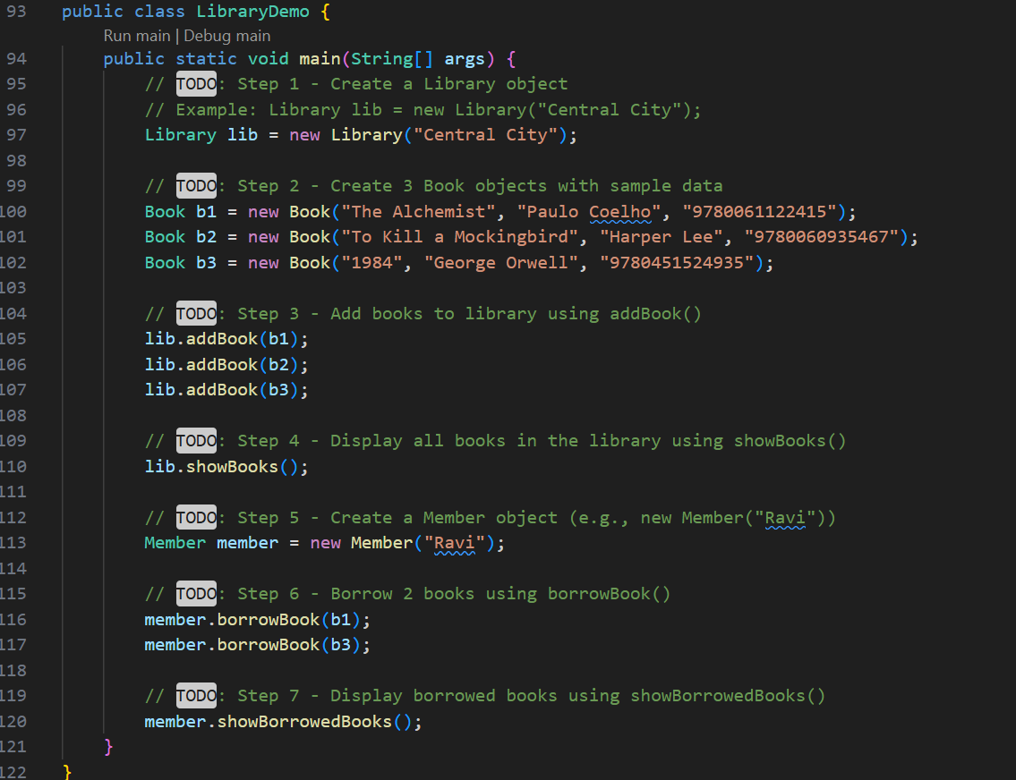

**OUTPUT🡪**

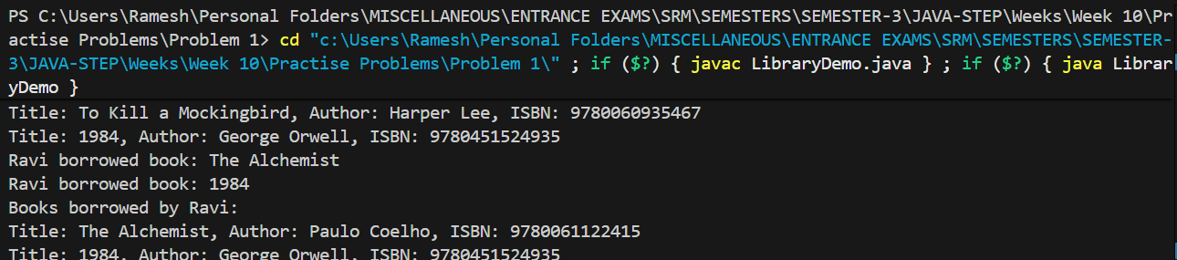

**QNO2🡪**

Design a simple Online Shopping System that represents the

relationship between Customer, Order, and Product objects.

● A Customer can place multiple Orders.

● Each Order contains multiple Products.

● Each Product has a name and price.

● A Customer object has personal details like name and email.

ShopingDemo.java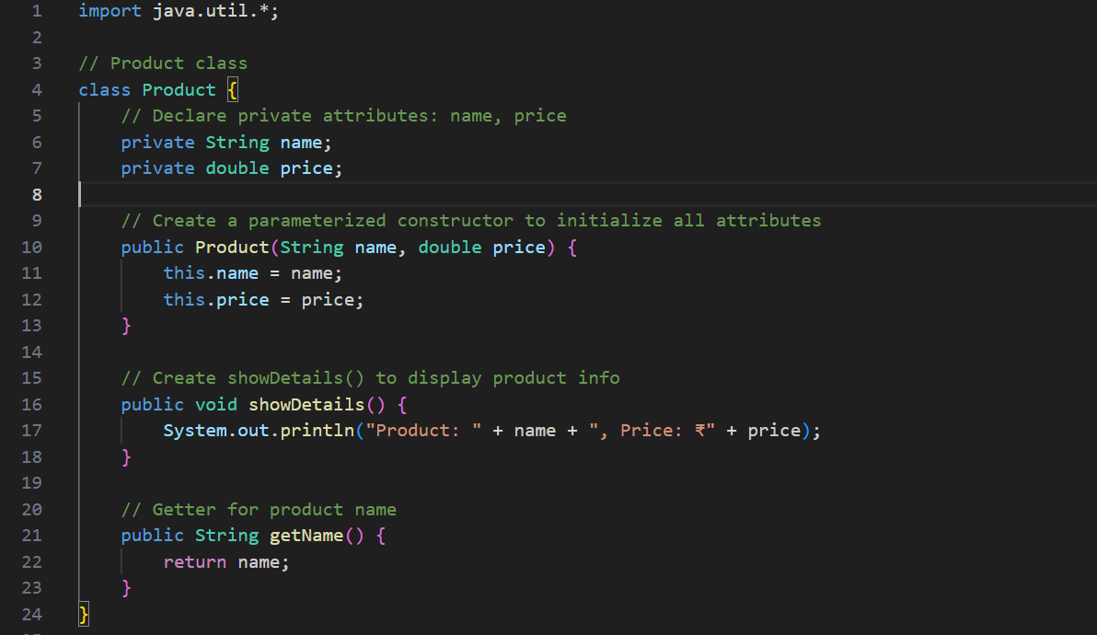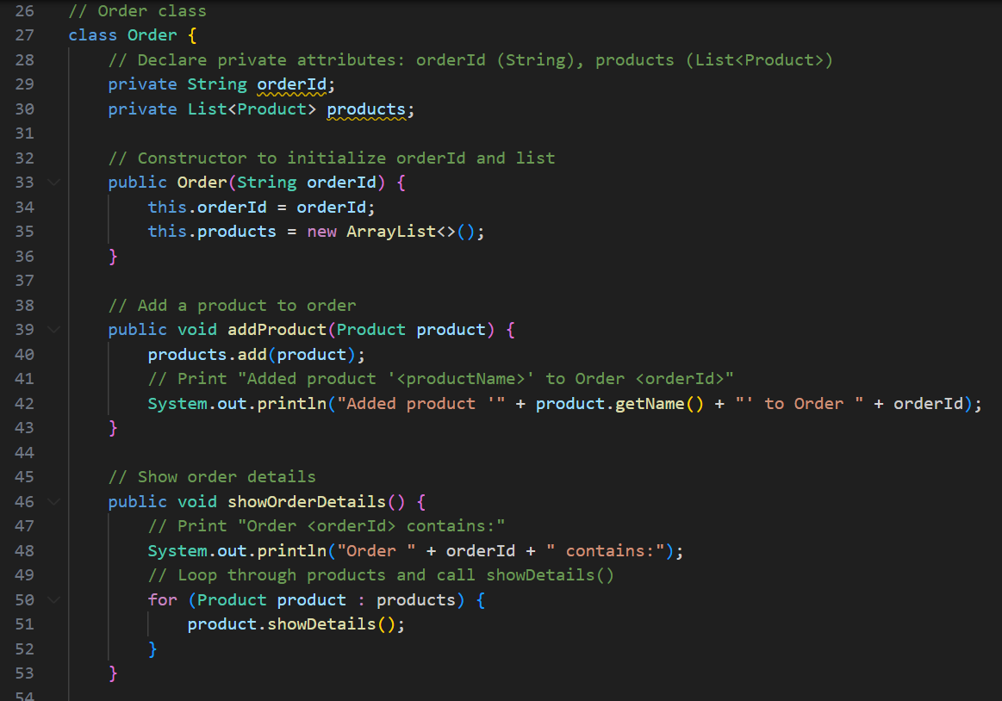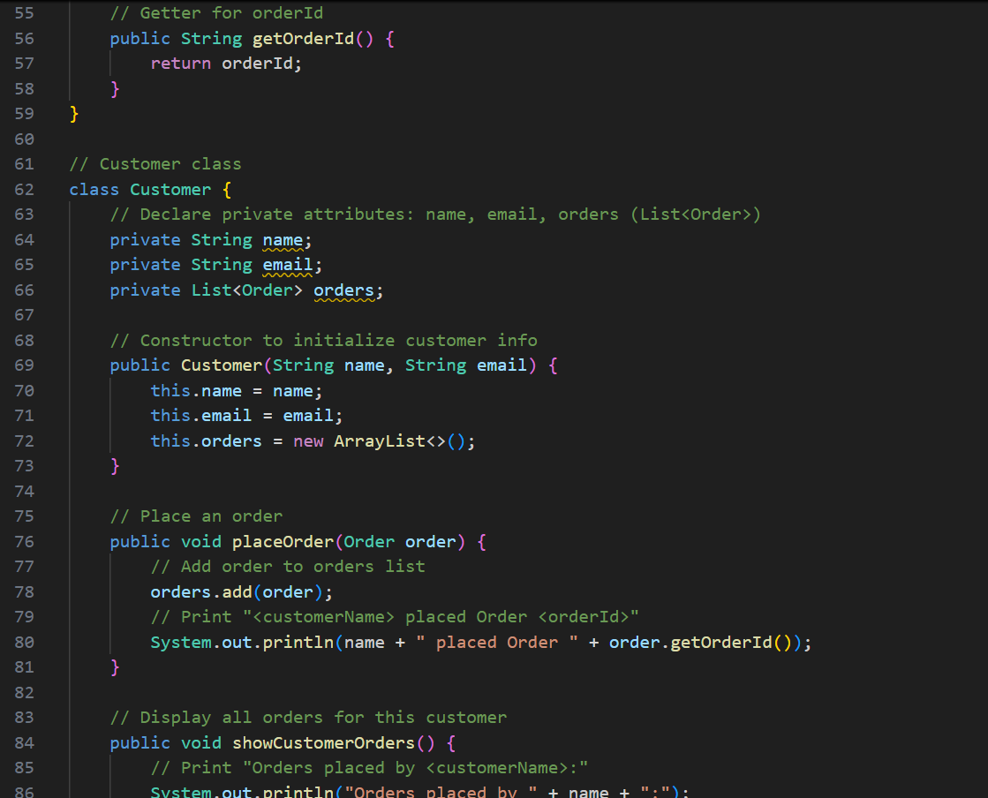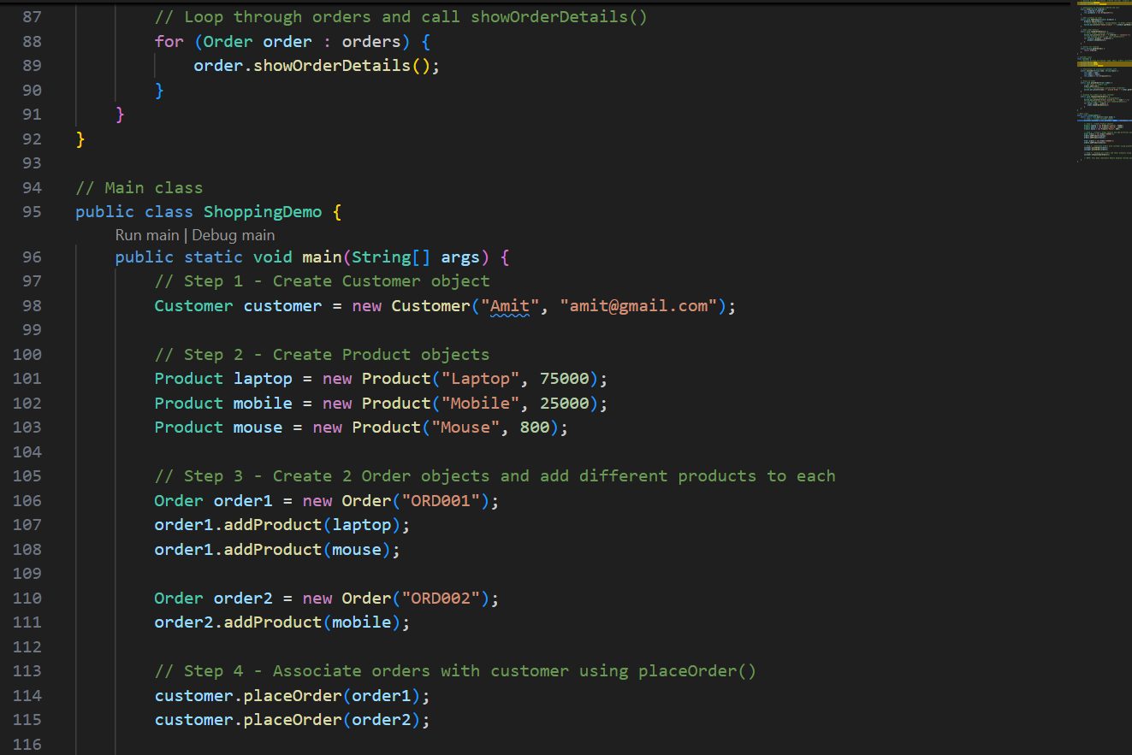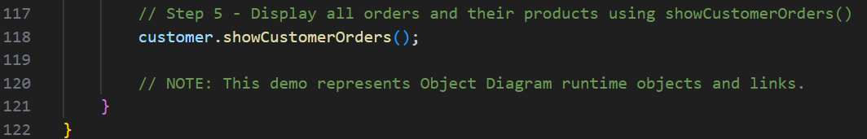

**OUTPUT🡪**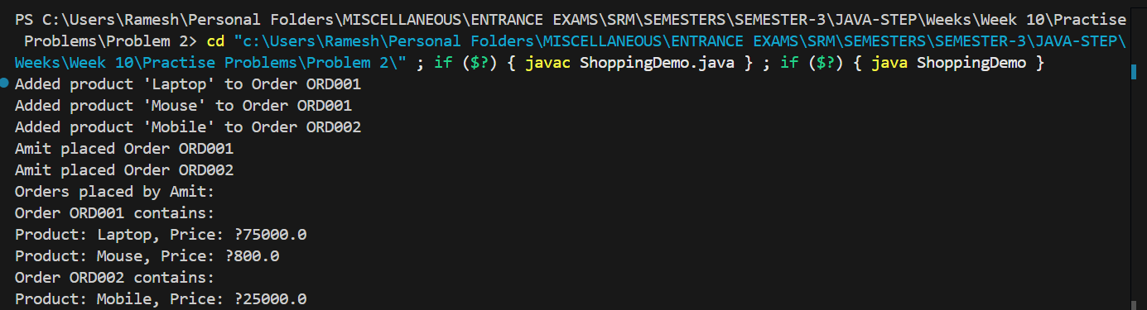

**QNO3🡪**

Design a Sequence Diagram that models an ATM withdrawal process between a

Customer, ATM, and BankAccount.

When a customer inserts a card and requests withdrawal:

1. The Customer sends a request to the ATM.

2. The ATM verifies the PIN with the BankAccount.

3. If successful, the BankAccount processes the withdrawal.

4. The ATM dispenses the cash.

5. The Customer receives confirmation.

ATMDemo.java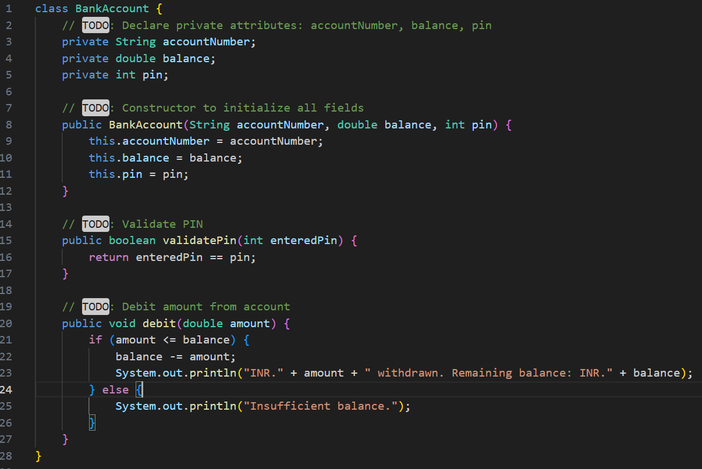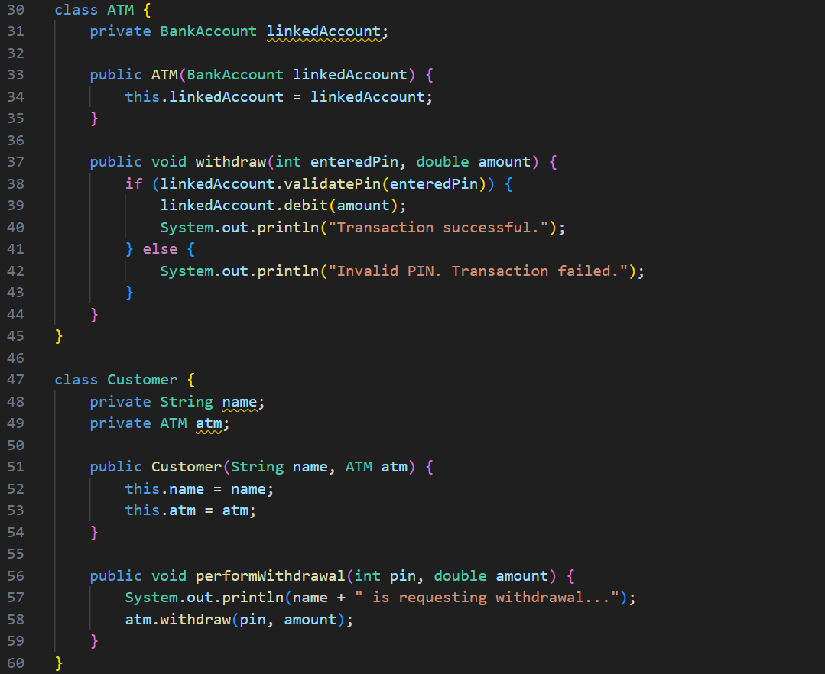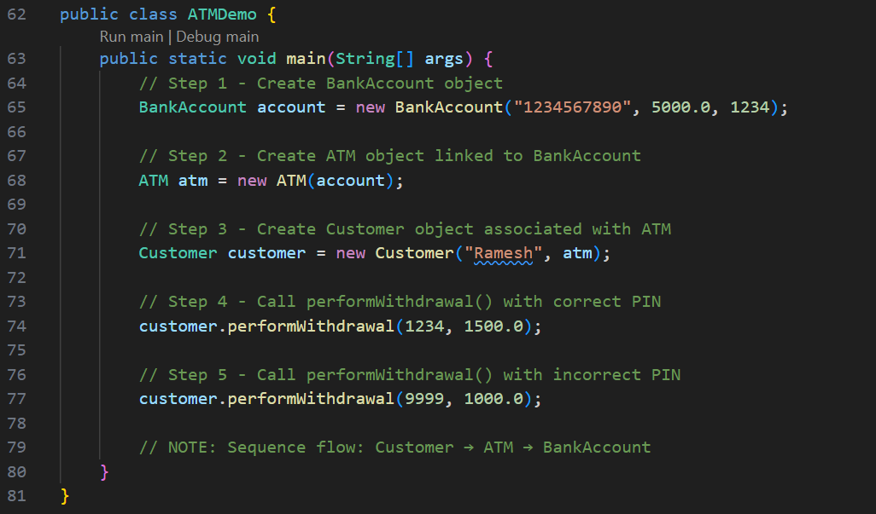

**OUTPUT🡪**